Economic Train Wreck Dead Ahead
We find ourselves in the situation where a stock market crash worse than 1929 (in which the Dow declined 89%) is a virtual certainty. Pension funds, endowments and personal retirement accounts are all at serious risk of almost total loss. So called “diversification” will basically offer no protection from a stock market and credit collapse.
I have always thought of the 1929 market crash and 1930s Depression as a sort of “worst case” economic scenario. In the 1950s it was generally understood that it was the credit excesses of the ‘20s that caused the 1929 Crash and Great Depression. The thinking was that the only real way to avoid the fallout from a destructive crash was to avoid creating a credit bubble in the first place. This is why the 1950s Federal Reserve Chairman quipped: “The Fed’s job is to take away the punch bowl just as the party is getting started.” By 1982 with the direct memory of the 1930s depression beginning to fade, policy makers once again began to “stimulate” the economy with borrowed dollars. By the mid-1990s we had exceeded the excesses of 1929 both in the amount of debt and in terms of stock prices. To call the current situation dangerous is a vast understatement. The 1929 excesses look tame compared to where we are today.

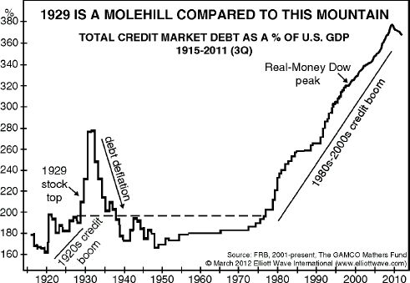
In the same fashion, that the only way to avoid a hangover is to not get drunk in the first place, excess borrowing to fuel an investment mania always leads from boom to bust. A 400 year study of financial markets has shown this to be true every time. It just makes sense. When the boom ends, the accumulated debt does not.
Why then, aren’t we more worried? Maybe it’s like frogs and boiling water. I’m told that if you throw a frog into boiling water, it will jump out, but that if you put it in warm water and slowly heat it, the frog gets used to it and stays immersed, well past the point at which it can survive. This strikes me as a valid analogy. Since 1982 every economic difficulty has been fixed with the magic of “adding liquidity”. Adding liquidity is nothing more than borrowing more money to “stimulate” the economy. What is most disturbing is that while the water continues to heat up, (debt bubble getting larger and larger) because it has been going on so long, most are ignoring the long term implications. Because debt has been expanding for the last 70 years fueling positive stock market returns, it is now considered to be a “given” that stocks will do well over “the long run”. Debt-wise, we have climbed to the peak of Mt. Everest. Is it wise to extrapolate climbing another 29,000 ft. because we’ve just climbed a long way? You may climb another mountain someday, but if you plan for the future based on the past while paying absolutely no attention to where you actually are, your next step will almost certainly turn into a fall from which you will not recover.
Starting in the early ‘80s many came to believe that deficits and debt don’t matter. We have recently lived through the 2000 .com bubble bursting which was an even bigger bubble than in 1929. But because, like the frogs in hot water, we have become “used to” huge debt, we were “comfortable” creating another bubble -- this time primarily by using real estate, which peaked in 2005 and soon created an even larger economic decline. We then watched in astonishment as seven years after the 2000 debacle the Dow dropped twice as far in roughly half the time. It’s not so complicated; more debt made things worse -- much worse. So now we have re-inflated the bubble a third time as of 2014. Currently there is 30% more debt worldwide than at the last peak in 2007 and we are experiencing one of the weakest recoveries of all time. All this borrowing has yielded only weak economic growth, and our national balance sheet keeps getting worse and worse. Thus the debt bubble gets bigger and bigger. Eventually it will pop, likely sooner than later. The bubble is much bigger than in 1929, so the economic destruction will be worse than in the 1930s!
Mount Everest Anyone?
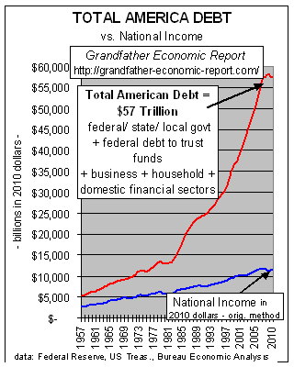
We’ve established that debt is too high and that every time in the past, this has led to a bust. Most would like to believe we will find some way out of this mess. But, with the amount of accumulated debt and the weakness of our current recovery, I think one has to admit that risk in our markets, particularly the stock market, is sky high. Yet the standard portfolio structure by which college foundations are measured is one of 60% stocks and 40% bonds. This kind of approach gives most portfolios absolutely no protection against a scenario that, barring some sort of miracle, would have to be judged as inevitable. Trillions are mistakenly invested this way.
A huge problem I see is that those making investment decisions for large institutions are required to justify their decisions to others. They are virtually required to utilize money managers who have established a “track record” or who have “proven” their ability to manage funds. Look at the above chart and think of the debt buildup as a great “wave”. Successfully investing over the last 30 years has been like riding a tsunami of credit expansion. When the tsunami hits shore (debt expansion can’t go on forever), no matter how good they have become at surfing, a crash will wipe them out. It’s my belief that most pension funds, foundations, individuals, and corporations that do not prepare for such an eventuality will be destroyed just like the devastation that occurs when any tsunami hits.
My own interest in finance is life-long, including even computing compound interest on my allowance when I was in grade school. I worked as a stock broker from 1983 to 2003. My career began with an exclusive focus on individual companies. The 1987 market crash provided a difficult but critical lesson on the importance of the general market. By the mid ‘90s I had become more familiar with market cycles and how broad economic forces can influence all markets. My concern grew as we began eclipsing the extremes in market prices and debt from the 1920s. The market continued to set new, significantly higher prices, and by 2003, I left the industry as I felt I could no longer make recommendations. After this, I sold operating businesses for a few years. I now see a unique opportunity to combine both careers by first taking advantage of the upcoming stock market decline and then by purchasing assets at bargain rates.
To anyone taking an objective look at where we are now, it is clear that our Titanic is headed for an iceberg. That’s why I am starting TEQ Investments, a unique company to take advantage of what I see as a one-time opportunity. I won’t be establishing a track record because there has never been a bigger debt tsunami and this will be a one-time event. I predict that taking refuge in the perceived safety of those who are successfully navigating the markets under current conditions will prove to be a costly mistake. When I listen to financial “experts” discussing corrections, buying opportunities and other various details of the markets, I can’t help but feel they aren’t considering the big picture. The majority of the decline in 2008 took place on only 8 trading days and nearly sank our whole economy. The primary culprit was too much debt and now we have even more! We have engineered an anemic recovery and new highs in the stock market, but we haven’t solved the underlying problem of too much debt. Rather, we have made it much worse.
My company, TEQ Investments, will be positioned to take advantage of the descent from this historic debt peak. Most people are not equipped to take an independent look at our current situation, so for those few who can, this is a giant opportunity. Some of the smaller indexes fell by 70 or 80 percent in the 2007–9 stock market debacle. Specialized financial instruments that I plan to employ rose to many times higher during that decline. This time should be worse, so the reward could be even greater. TEQ Investments has a twofold strategy: First, we will take advantage of the upcoming stock market decline, actually increasing our asset values even as the market declines. Then, in one to three years, we will begin looking for worthy companies to buy or invest in. Imagine how you would feel if you multiplied your capital during a major decline and then assets were selling for pennies on the dollar. What an opportunity!
I am offering you this opportunity to become a client of TEQ Investments which will allow you to hedge your future against loss. If you are an individual, this is an unprecedented opportunity to make huge returns while most are losing everything. If you are an operating company, TEQ Investments gives you a chance to stay in business when everything else is collapsing. If you are an endowment or pension fund, investing a small portion of your assets will allow you to maintain your assets instead of watching 80 or 90 percent of them disappear.
This is not an attempt at market timing. The world has never seen a debt bubble of this size, so this is a one- time challenge/opportunity. Calling for the end of a mania is a difficult undertaking and this mania has proven to be longer lasting than anyone could have reasonably predicted. What is important is that the longer this mania lasts, the more complacent many become, and the higher the risk becomes. This explains why we have record numbers of Americans receiving food stamps at the same time that the stock market and investor optimism are setting new records highs. Things aren’t OK, but we have propped up the markets for so long that people believe it will last forever. It won’t. Many warning lights are flashing red right now. The sell-off since the beginning of the year looks ominous. A year before the 1929 crash interest rates started rising while commodity prices fell indicating a risk of deflation – or collapse in prices. The same scenario is true today.
One more point I would like to emphasize. Positioning ourselves in the market now to multiply funds to use for investment at much lower levels; will later provide an important boost to the economy when it needs it most. Keeping cash strapped businesses operating will provide jobs and growth when both will be desperately needed. Providing jobs after an economic calamity will go well beyond the huge investment returns I feel will be likely. It will be an important support for our country.
Lastly, this is an amazing once in several centuries opportunity. The amount of debt worldwide should give anyone cause for concern. A portfolio of stocks, bonds, real estate or commodities will suffer across the board when all this debt we have built up begins to deflate. You have to consider it to be at least an urgent and real possibility. Investing in TEQ Investments will serve as an insurance policy in a frightening period of unprecedented debt collapse.

Thomas E. Meyer, President
February 2014
TEQ Investments 2429tom@gmail.com 612-419-7977

